Central tendency, variability, and skewness

📊 Python & Pandas Statistical Commands — Cheat Sheet (Table Format)

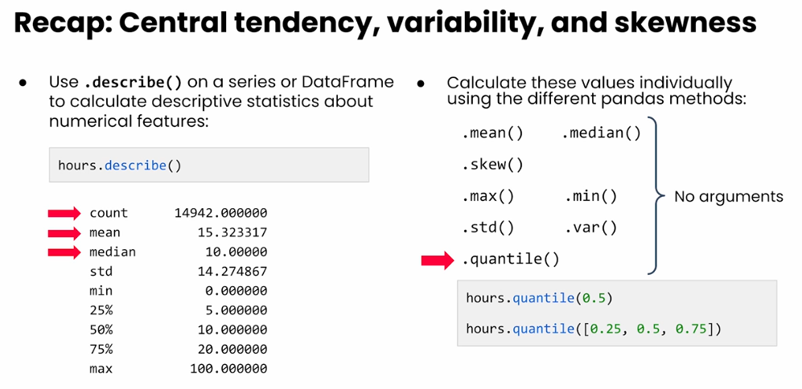

✔ Descriptive Statistics
Purpose | Command | Output
Summary of all numeric columns | df.describe() | count, mean, std, min, quartiles, max
Mean | df['col'].mean() | Average
Median | df['col'].median() | Middle value
Mode | df['col'].mode() | Most frequent value(s)
Standard deviation | df['col'].std() | Spread of values
Variance | df['col'].var() | Variability
Min | df['col'].min() | Minimum
Max | df['col'].max() | Maximum
Sum | df['col'].sum() | Total
Count (non-NA) | df['col'].count() | Number of values

✔ Distribution & Quantiles
Purpose | Command
Quantile | df['col'].quantile(0.25)
Multiple quantiles | df['col'].quantile([0.25, 0.5, 0.75])
Value counts | df['col'].value_counts()
Relative frequencies | df['col'].value_counts(normalize=True)
Unique values | df['col'].unique()
Number of unique values | df['col'].nunique()

✔ Grouped Statistics
Purpose | Command
Group by column and compute mean | df.groupby('col').mean()
Group by multiple columns | df.groupby(['A','B']).mean()
Grouped summary | df.groupby('col').describe()
Apply custom agg | df.groupby('col').agg(['mean','std','count'])

✔ Correlation & Covariance
Purpose | Command
Correlation matrix | df.corr()
Correlation of two variables | df['A'].corr(df['B'])
Covariance matrix | df.cov()
Covariance of two variables | df['A'].cov(df['B'])

✔ Handling Missing Data
Purpose | Command
Check missing per column | df.isna().sum()
Remove missing rows | df.dropna()
Fill missing with constant | df.fillna(0)
Fill missing with mean | df['col'].fillna(df['col'].mean())

✔ Data Filtering
Purpose | Command
Filter rows | df[df['col'] > 10]
Filter with multiple conditions | df[(df['A']>10) & (df['B']=='X')]
Select columns | df[['col1','col2']]
Random sample | df.sample(5)

✔ Data Transformations
Purpose | Command
Create new column | df['new'] = df['old'] * 2
Apply function | df['col'].apply(lambda x: x*2)
Rename columns | df.rename(columns={'A':'new_A'})
Sort by column | df.sort_values(by='col')
Normalize column | (df['col'] - df['col'].mean()) / df['col'].std()

✔ Plotting (pandas built-in)
Purpose | Command
Histogram | df['col'].hist()
Boxplot | df.boxplot(column='col')
Scatterplot | df.plot.scatter(x='A', y='B')

📦 Pandas Commands for Categorical Data — Cheat Sheet (Table)

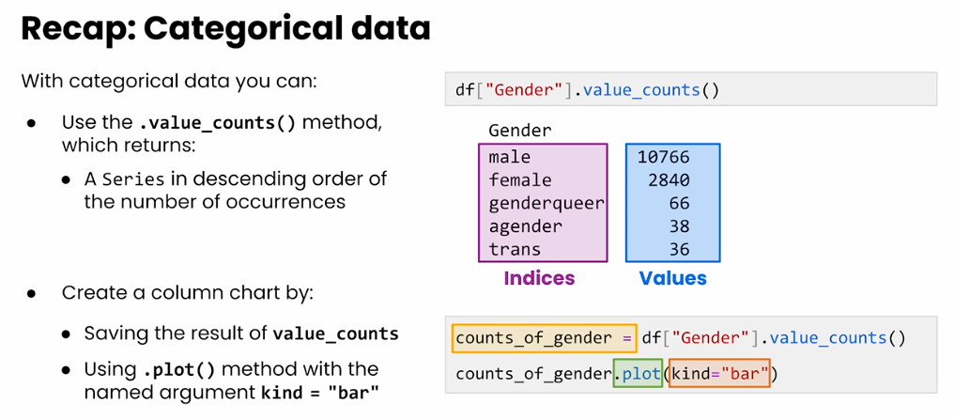

🔍 Identify Categorical Columns
Task | Command | Notes
Show data types | df.dtypes | Categorical columns usually appear as object

📊 Value Counts (Most Important Tool)
Task | Command | Output
Count category frequencies | df['col'].value_counts() | Series with index = category names, values = counts
Save counts | counts = df['col'].value_counts() | Useful for plotting
Normalize (percentages) | df['col'].value_counts(normalize=True) | Proportions instead of counts
Top 5 categories | df['col'].value_counts().head(5) | Best for large-category columns
Number of unique categories | df['col'].nunique() or len(df['col'].value_counts())

📦 Series Properties
Task | Command | Meaning
Check type | type(counts) | Usually <class 'pandas.core.series.Series'>
List unique categories | df['col'].unique() | Returns array of categories

📊 Plotting Categorical Distributions

Basic bar chart
Task | Command
Bar chart from value counts | counts.plot(kind='bar')
Top 5 only | df['col'].value_counts().head().plot(kind='bar')

“Better looking” bar chart
(Using only .plot() args, as in your lesson.)
counts.plot(
kind='bar',
figsize=(10, 6),
title='Gender Distribution',
xlabel='Gender',
ylabel='Count',
rot=45
)

🧠 Lessons (Concept Summary)
- Categorical data = use .value_counts() instead of histograms.
- .value_counts() returns a Series:
  - index = category labels
  - values = counts
- You can plot this directly using:
  - .plot(kind='bar')
- Large cardinality columns (e.g., 148 languages) → use .head() to simplify.
- .unique() & .nunique() help understand category diversity.
- .plot(kind='column') ❌ invalid — use "bar" instead.

📚 Quick Table: Pandas Categorical Commands
Category | Command | What it Does
Inspect categorical column | df['col'] | Select column
Count categories | df['col'].value_counts() | Most common starting point
Percent frequencies | df['col'].value_counts(normalize=True) | % per category
Return unique labels | df['col'].unique() | Shows category list
Number of categories | df['col'].nunique() | Count of unique categories
Save counts | counts = df['col'].value_counts() | For reuse
Top 5 | counts.head(5) | Most common categories
Plot categorical distribution | counts.plot(kind='bar') | Bar plot
Plot top 5 | df['col'].value_counts().head().plot(kind='bar') | Focused plot

📓 Jupyter Notebook: Categorical Data Analysis in Pandas

📌 1. Setup & Load Data
import pandas as pd

# Load data
df = pd.read_csv('your_dataset.csv')

# Set index (optional)
df = df.set_index('id')

df.head()

📌 2. Identify Categorical Columns
df.dtypes
Typical output shows object columns = categorical.

📌 3. Analyze Gender Distribution

Value Counts
gender_counts = df['gender'].value_counts()
gender_counts

Plot the distribution
gender_counts.plot(
kind='bar',
figsize=(8, 5),
title='Gender Distribution',
rot=45,
ylabel='Count',
xlabel='Gender'
)

📌 4. Analyze Top 5 Languages Spoken at Home

Value counts
lang_counts = df['language_at_home'].value_counts()
lang_counts.head()

Plot only the top 5
lang_counts.head().plot(
kind='bar',
figsize=(8, 5),
title='Top 5 Languages Spoken at Home',
xlabel='Language',
ylabel='Count'
)

📌 5. Useful Categorical Insights
unique_languages = df['language_at_home'].nunique()
unique_languages
df['language_at_home'].unique()[:10] # preview first 10 unique values

📌 6. Cross-Tabulation (Bonus)
(Optional: exploring relationships)
pd.crosstab(df['gender'], df['software_developer'])

📌 7. Summary Table of Categorical Stats
{
"Gender Distribution": gender_counts,
"Top 5 Languages": lang_counts.head(),
"Number of Unique Languages": unique_languages
}

🎓 Exercises + Fully Worked Solutions

Exercise 1 — Gender Distribution
Task:
- Compute the category counts for the gender column.
- Convert the counts into percentages.

✅ Solution
gender_counts = df['gender'].value_counts()
gender_percent = df['gender'].value_counts(normalize=True) * 100

gender_counts, gender_percent

Exercise 2 — Most Common Spoken Languages
Task:
- Get the top 10 most common languages.
- Plot only the top 5.

✅ Solution
lang_counts = df['language_at_home'].value_counts()
top10 = lang_counts.head(10)
top5_plot = top10.head(5).plot(kind='bar')

Exercise 3 — Number of Unique Categories
Task:
Find:
- How many unique values exist in these categorical columns:
  - gender
  - country_of_residence
  - language_at_home

✅ Solution
df['gender'].nunique(), df['country_of_residence'].nunique(), df['language_at_home'].nunique()

Exercise 4 — Create a Crosstab
Task:
Create a cross-tabulation showing counts of gender by software developer status.

✅ Solution
pd.crosstab(df['gender'], df['software_developer'])

Exercise 5 — Bar Plot Customization
Task:
Plot the top 5 genders with:
- figsize=(9,6)
- title "Gender Breakdown"
- x-label = "Gender"
- y-label = "Frequency"
- rotate labels by 45 degrees

✅ Solution
df['gender'].value_counts().head().plot(
kind='bar',
figsize=(9, 6),
title='Gender Breakdown',
xlabel='Gender',
ylabel='Frequency',
rot=45
)

Exercise 6 — Compare Value Counts vs. Unique
Task:
Explain the difference between:
- .value_counts()
- .unique()
- .nunique()

✅ Solution Explanation
Method | What it Returns
.value_counts() | Count of each category (sorted, Series)
.unique() | Array of all category names (unsorted)
.nunique() | Number (integer) of unique categories

Exercise 7 — Identify Rare Categories
Task:
Find all languages spoken by fewer than 50 people.

✅ Solution
rare_langs = df['language_at_home'].value_counts()
rare_langs[rare_langs < 50]

Exercise 8 — Filtering Based on Category
Task:
Filter dataset to show only rows where:
- gender = "Female"
- language_at_home = "Spanish"

✅ Solution
df[(df['gender'] == 'Female') & (df['language_at_home'] == 'Spanish')]

📊 Pandas Statistics — Exercises & Commands (Table Format)
Exercise | Command(s)
1 | mean = grades['score'].mean()  median = grades['score'].median()  print("The mean of the scores is: ", mean)  print("The median of the scores is: ", median)
2 | stdev = grades['score'].std()  print("The standard deviation of the scores is: ", stdev)
3 | skewness = grades['score'].skew()  print("The skewness of the scores is: ", skewness)
4 | score_percentiles = grades['score'].quantile([0.25, 0.5, 0.75])  print("The 25th percentile score is: ", score_percentiles[0.25])  print("The 50th percentile score is: ", score_percentiles[0.5])  print("The 75th percentile score is: ", score_percentiles[0.75])
5 | grades['participation'].value_counts()

